1. Agenda:
   1. Let’s deploy our first app on cloud.
   2. We will use Elastic BeanStalk to deploy our app.
2. First, we will login as IAM user.
3. 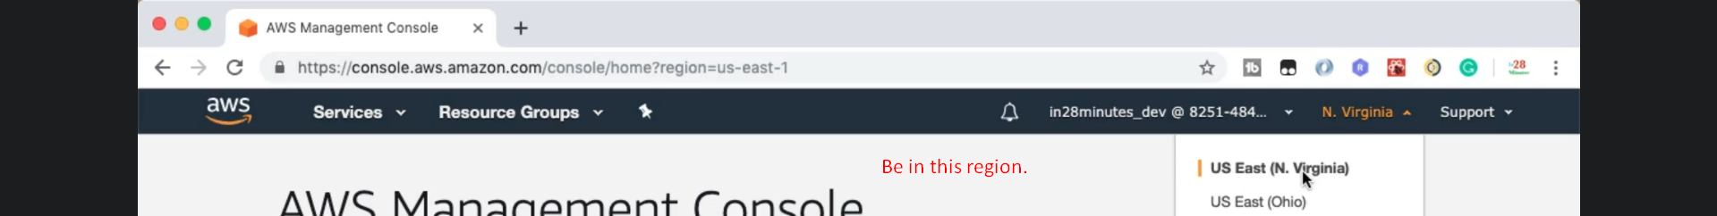
4. 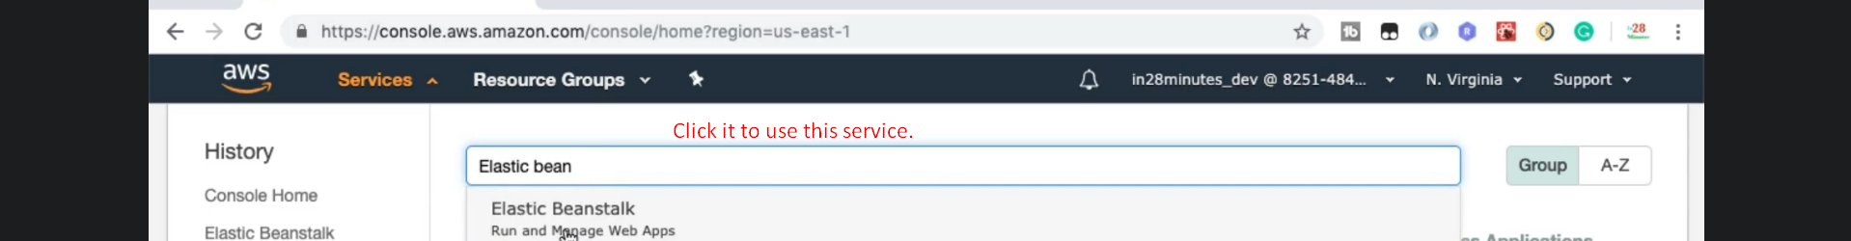
5. 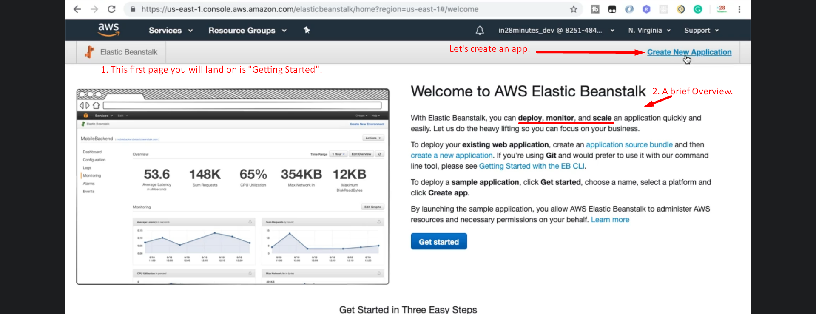
6. 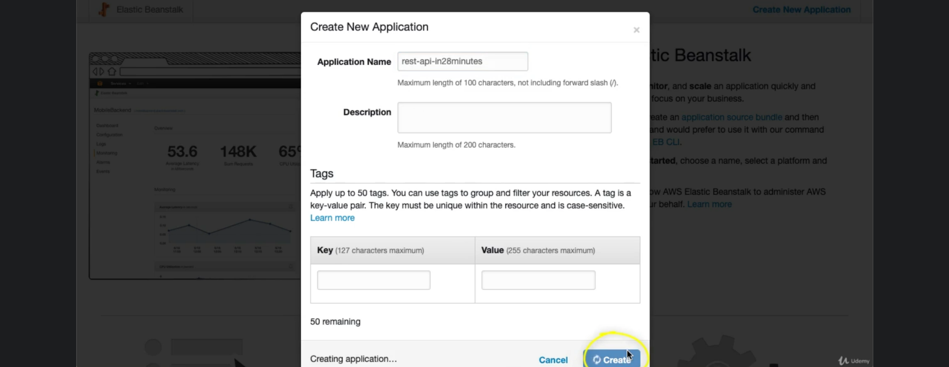  
   **NOTE**: Nothing is deployed. We just created an App.
7. 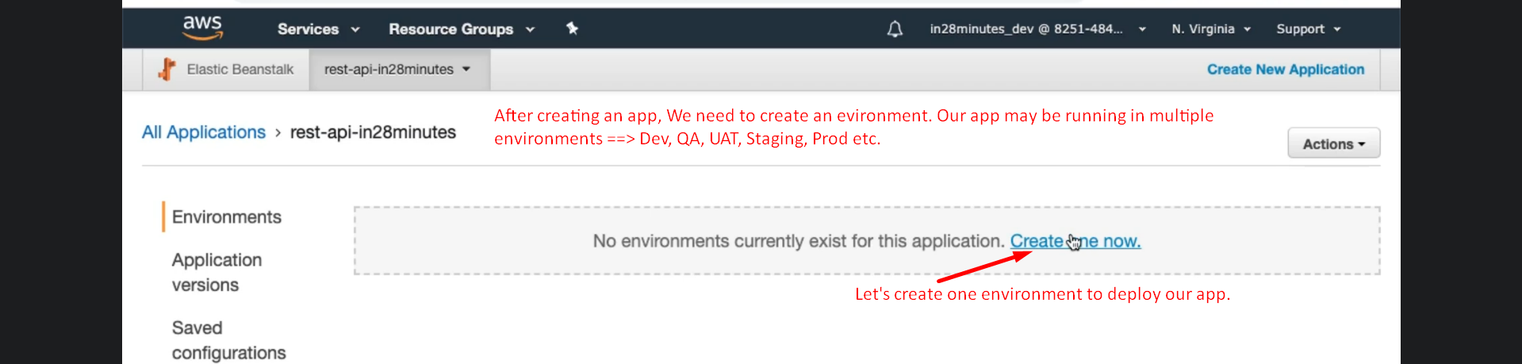
8. Creating an Environment.  
   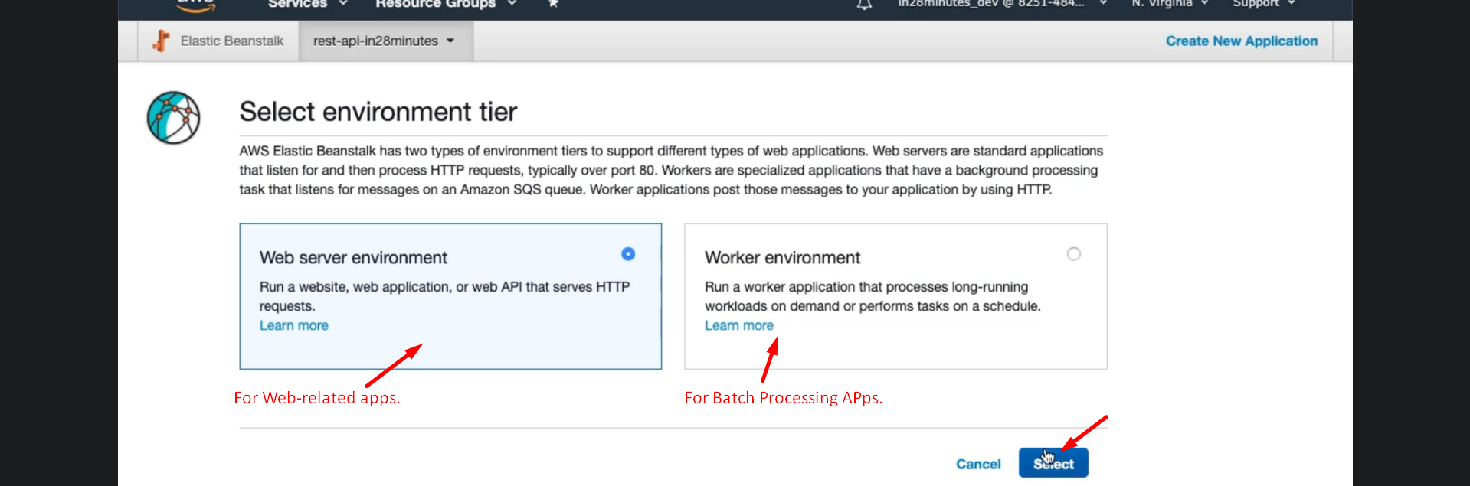  
   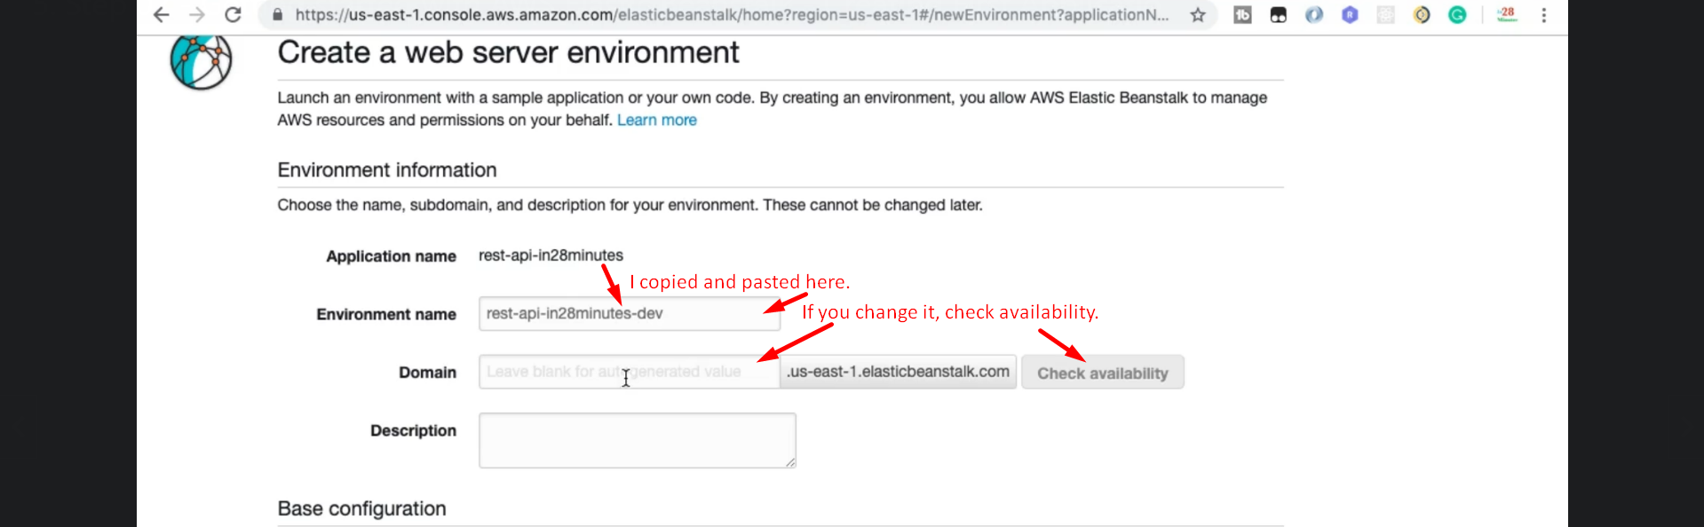  
   We will be deploying two kinds of Apps.   
   🡪 JAR file  
   🡪 War file.  
     
   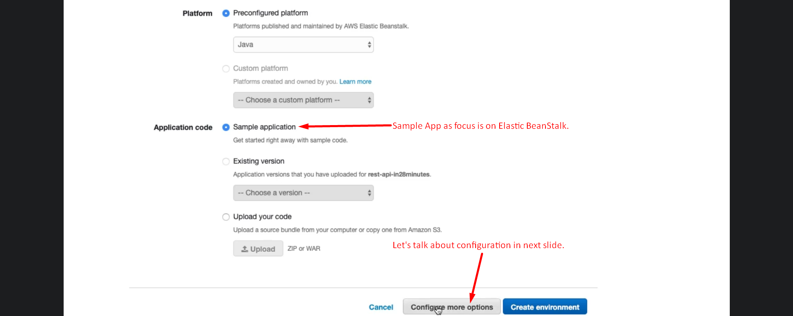  
   Configurations: In this option, we can configure different things about the environment.  
   🡺 Environment Variables

* Configuration about the AWS Instance where app would be running in.  
  
* Capacity: How many instances.
* Load Balancer: When more than one instance.
* Security.
* How to monitor an app.
* DB Creation.

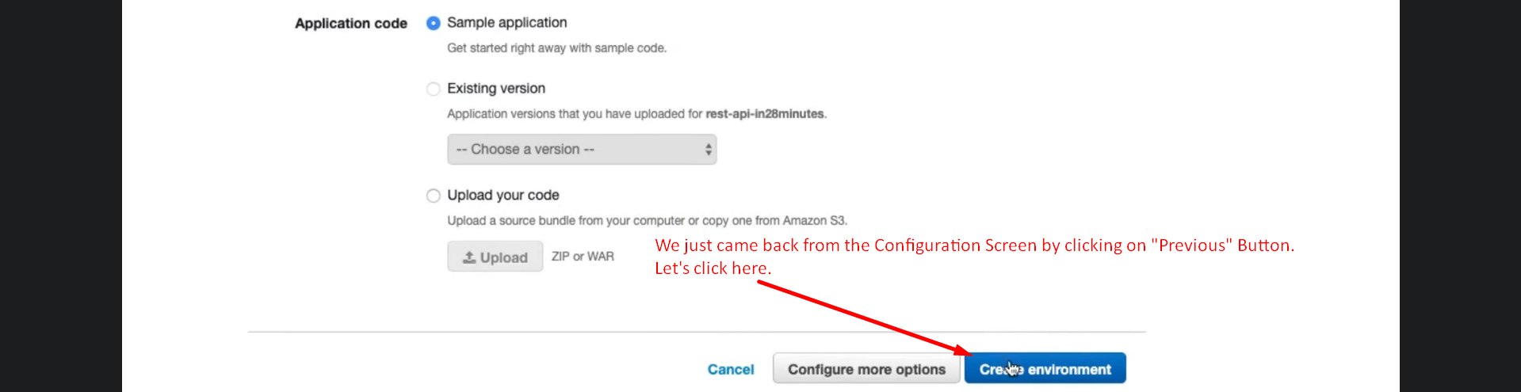

1. 